Unknown B
Aubrie Lisenby
28 November 2023
Chem 2081-003

Introduction
Identifying unknown compounds is a crucial skill in the chemistry field because it has a wide range of applications such as pharmaceuticals, environmental analysis, and material sciences. Through combining different analytical techniques, specifically Nuclear Magnetic Resonance (NMR), Fourier Transform Infrared Spectroscopy (FTIR), and Mass Spectrometry (MS), the molecular structure of unknown substances can be determined. The use of these techniques allows for an analysis that leads to compound identification.

Body
Nuclear Magnetic Resonance or NMR gives detailed information about the arrangement of atoms within a molecule and shows the connectivity and symmetry. On the other hand, Fourier Transform Infrared Spectroscopy or FTIR focuses on the vibrational modes of molecular bonds and aids in the identification of functional groups. Mass Spectroscopy or MS provides insights into the mass and composition of molecular fragments. It determines molecular weight and structural features.
NMR spectroscopy uses the magnetic properties of atomic nuclei, typically hydrogen or carbon-13. When the nuclei are placed in a strong external magnetic field, they align with or against the field. Then the radiofrequency pulses disrupt the alignment and cause the nuclei to absorb energy. As the nuclei are returning back to their original state, the signals they emit are detected and create a spectrum. The chemical shifts within the spectrum specify for the electronic environment around the specific nuclei. The coupling patterns show connectivity between neighboring nuclei. NMR provides insight into molecular structure, conformation, and dynamics of atoms within a molecule.
FTIR spectroscopy involves exposing a sample to infrared radiation, which results in the excitation of molecular vibrations. The bonds between atoms absorb specificwavelengths of infrared light, which causes peaks in the resulting spectrum. These peaks are characteristic for the atoms and bonds in between. The FTIR measures the transmittance and absorbance of the wavelengths of infrared light. This gives information about the functional groups that are in a specific compound. The peaks in the spectrum correspond to specific vibrational modes, which allows for the identification of the chemical bonds and assists in the qualitative and quantitative analysis of complex mixtures.
Mass spectrometry is a technique for measuring the mass-to-charge ratio of ions. The process involves ionization of the sample, fragmentation of molecules into ions, and separation of these ions based on their mass. The mass spectrum that results displays peaks that correspond to different fragments. This allows for the determination of the molecular weight and the structural information. Mass spectrometry is a versatile process that uses various ionization techniques such as electron impact, chemical ionization, and electrospray. Each of these s accommodates different types of compounds. Mass spectrometry is critical to identify unknown substances, interpret the composition of a substance, and offers insight into the chemical structure of a substance.

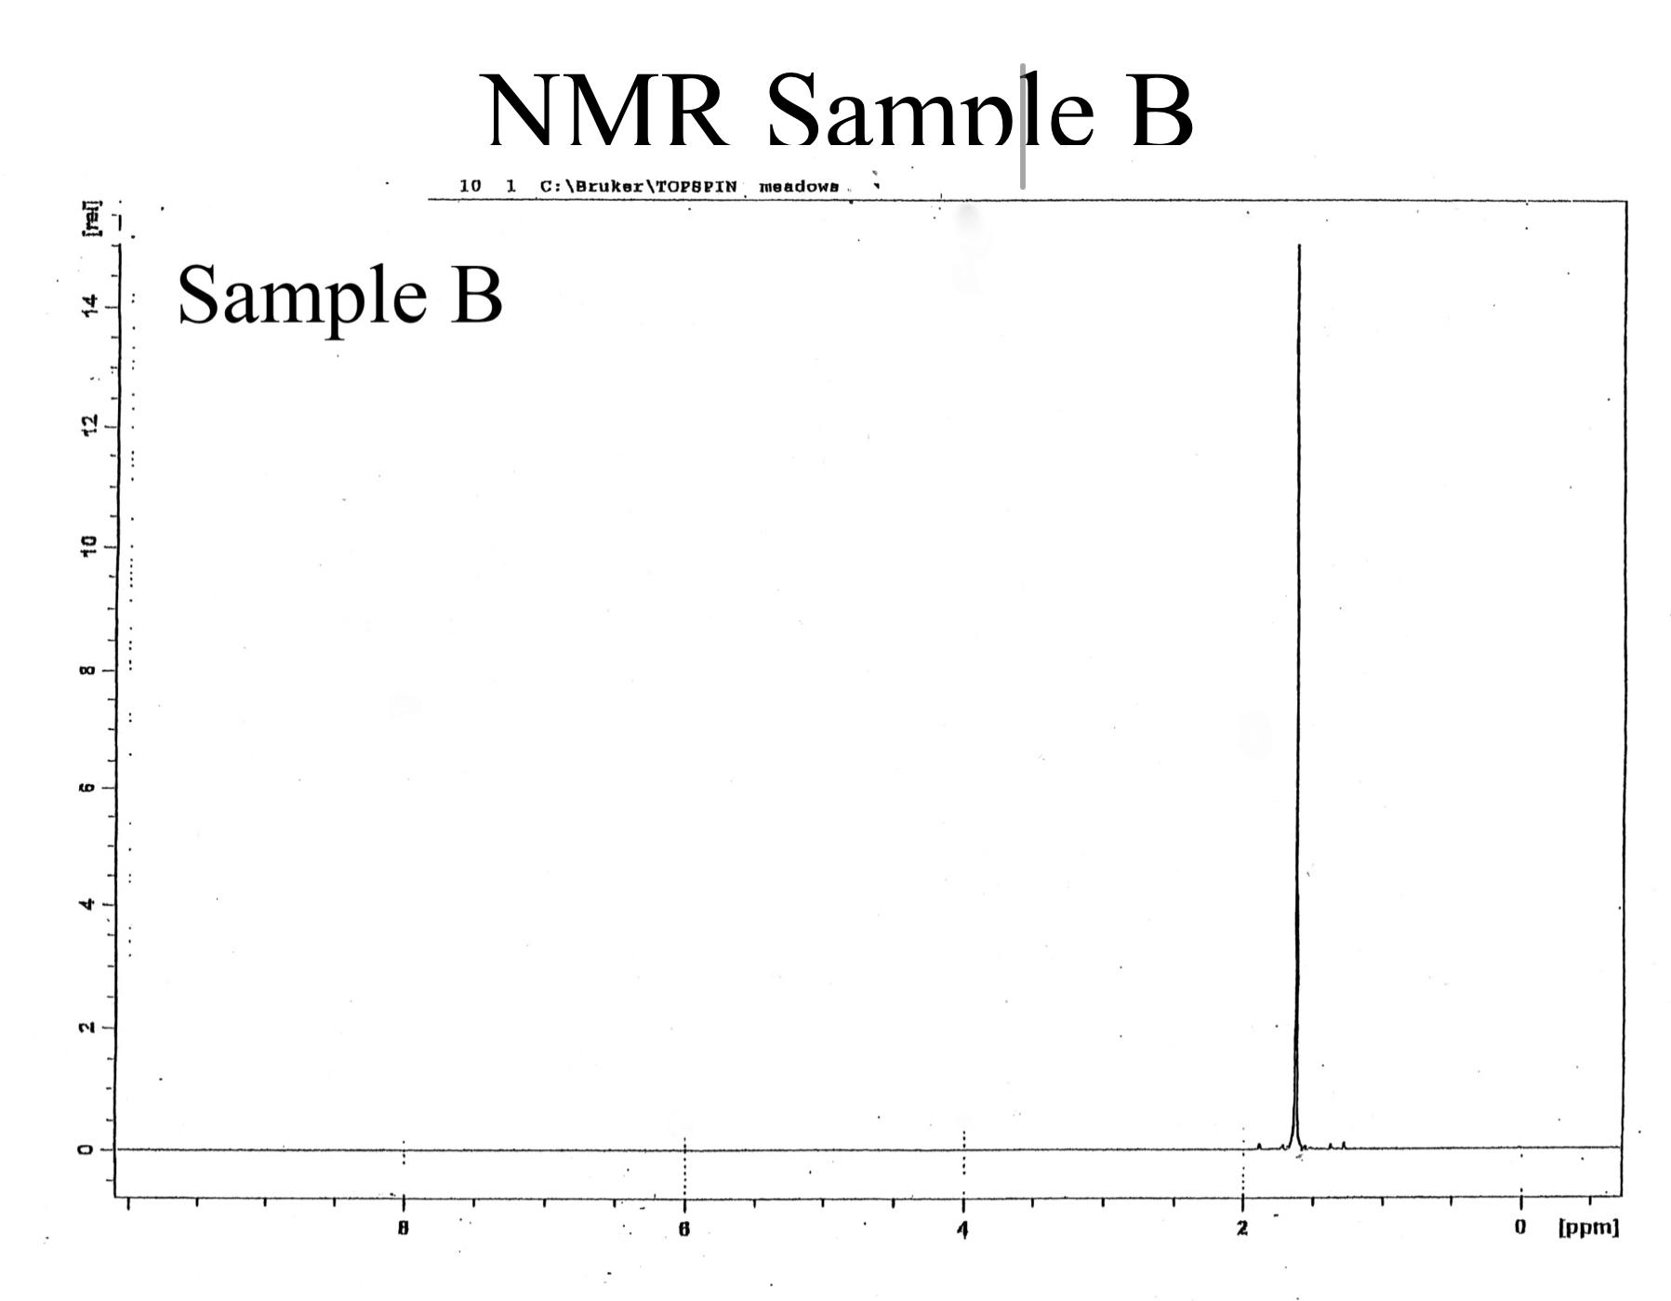
Data
Figure 1. NMR of sample B.

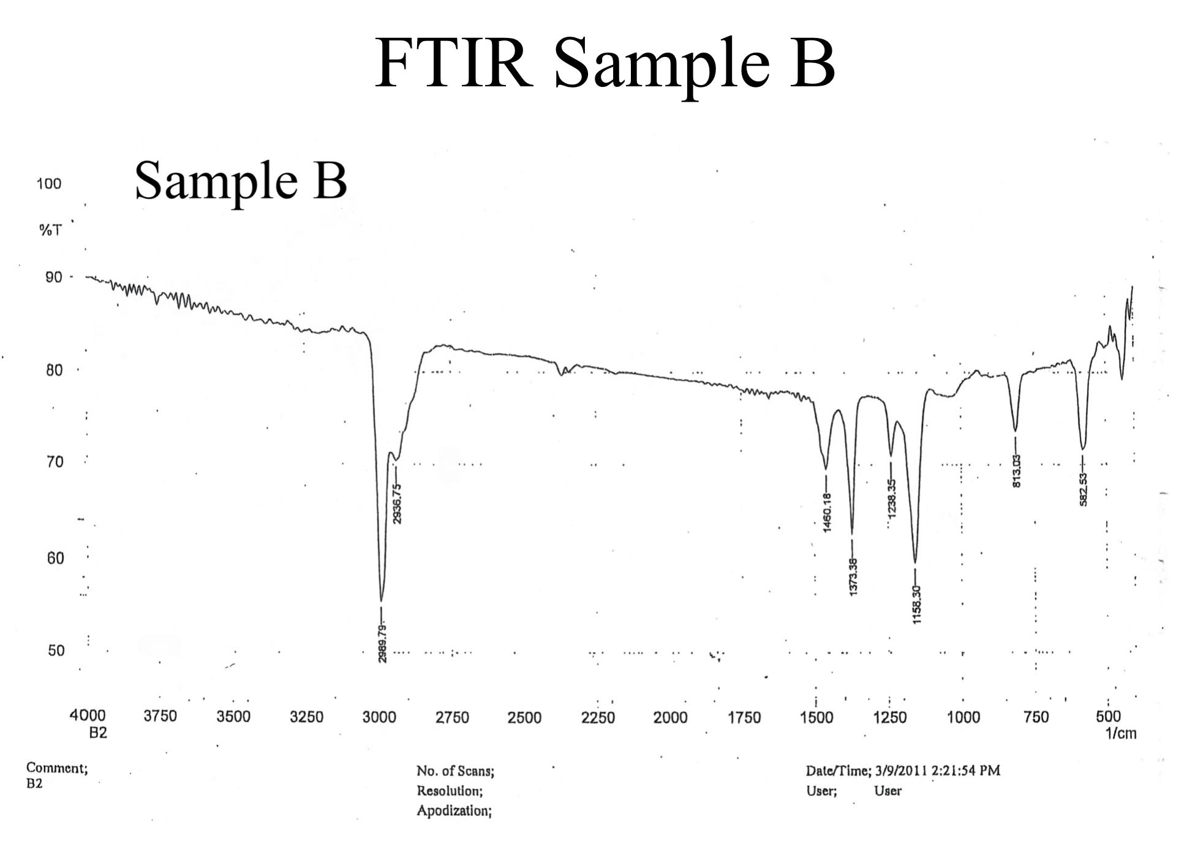
Figure 2. FTIR of sample B.
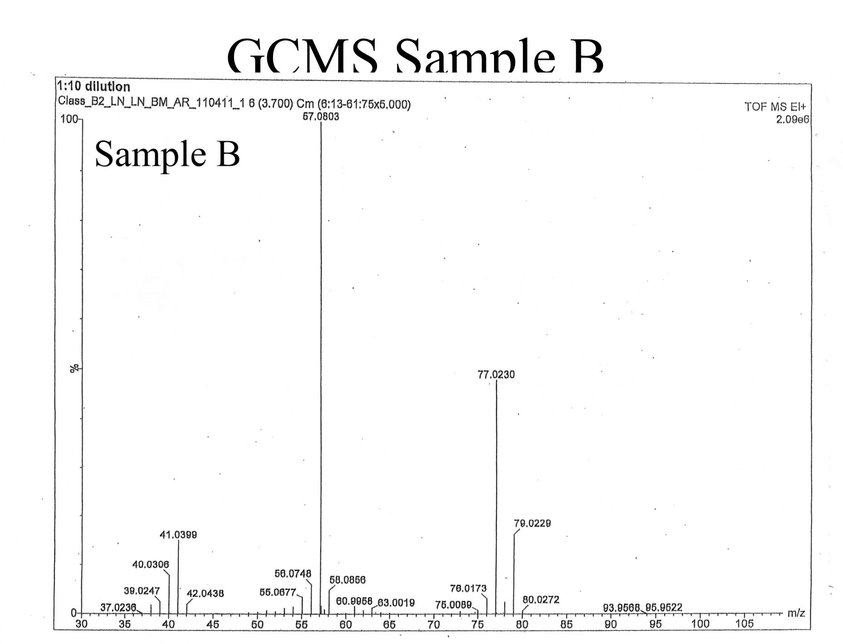Figure 3. GCMS of sample B.
Analysis
In the NMR spectrum, a singular peak is observed at about 1.6 ppm. The primary protons registered at 1.1 to 1.2 ppm, which suggests that there is a presence of a chloride atom in the compound inducing a downfield shift. The solitary peak demonstrates a sole proton type, and the height implies that there are multiple protons contributing to the signal.
In the FTIR analysis, the absence of activity above 3000 cm⁻¹ excludes an alcohol group. The peaks at 2989.79 and 2936.75 indicate that there are C-H bonds in the compound. The lack of peaks at 1600-1700 cm⁻¹ rules out the presence of any double or triple bonds within the compound. The signals between 1500- 100 cm⁻¹ show that there is a methyl group within the compound. The peaks at 813.03 and 582.83 confirm that there is a carbon-chlorine bond.
In the GCMS spectrum, the base peak at 57 m/z suggests a cationic formula of C₄H₉. The (M+1)+ peak at 77 and (M+2)+ peak is at 79. This is about one third of the height of (M+1)+ indicating the presence of a chlorine atom. The molecular ion peak at 93 aligns with the chemical formula of tert-Butylchloride.
Conclusion
In conclusion, unknown sample B can be analyzed using NMR, FTIR, and GCMS spectra. The NMR spectrum indicated that there was a single type of proton that was being affected by a chloride atom, which produced a downfield shift. The FTIR results revealed that there were no alcohol groups, double bonds, or triple bonds. It revealed the presence of C-H bonds, a methyl group, and a C-Cl bond. The GCMS spectrum had a base peak at 57 m/z, which supported a cationic formula of C₄H₉. The presence of a chlorine atom was confirmed by the (M+1)+ and (M+2)+ peaks.
After the analysis of NMR, GCMS, and FTIR, it is concluded that the unknown chemical compound B is tert-Butylchloride or 1-chloro-3-methylpropane. The chemical structure of it is shown below.
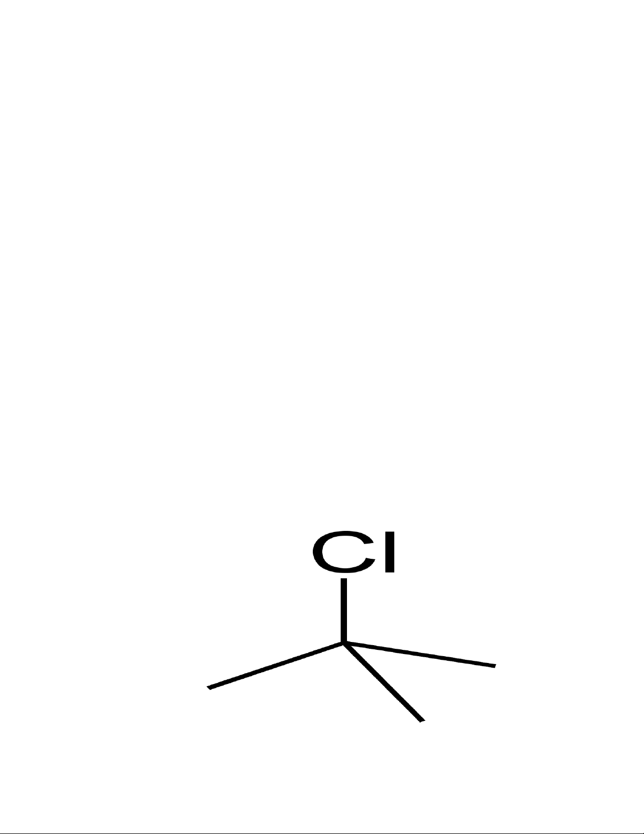
Figure 4. tert-Butylchloride

References
Keller L, Joseph K, and Miguel S. 2023 Fall. CHEM 2081 Organic Chemistry II Lab Manual [lab manual]. Auburn (Al): Auburn University.

